Key Words from a Transcript
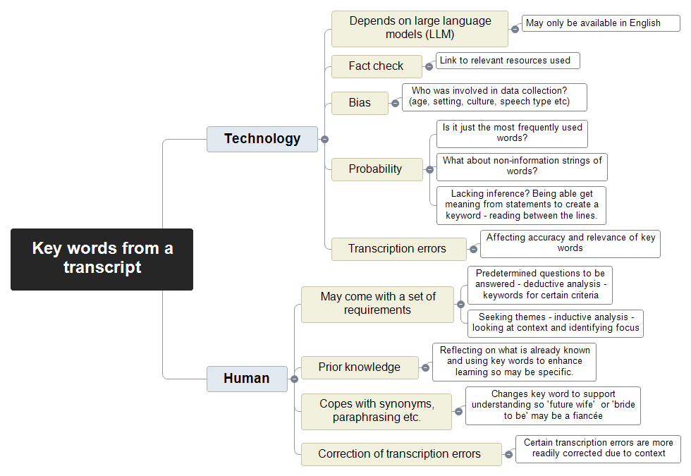

Technology

Depends on large language models (LLM)

May only be available in English
https://cdt.org/insights/lost-in-translation-large-language-models-in-non-english-content-analysis/

Fact check

Link to relevant resources used

Bias

Who was involved in data collection? (age, setting, culture, speech type etc)
https://aclanthology.org/2022.lrec-1.680.pdf

Probability

Is it just the most frequently used words?

What about non-information strings of words?

Lacking inference? Being able get meaning from statements to create a keyword - reading between the lines.

Transcription errors

Affecting accuracy and relevance of key words

Human

May come with a set of requirements

Predetermined questions to be answered - deductive analysis - keywords for certain criteria

Seeking themes - inductive analysis - looking at context and identifying focus

Prior knowledge

Reflecting on what is already known and using key words to enhance learning so may be specific.

Copes with synonyms, paraphrasing etc.

Changes key word to support understanding so 'future wife' or 'bride to be' may be a fiancée

Correction of transcription errors

Certain transcription errors are more readily corrected due to context

